Exercise 1 PowerShell Core 7 using VS Code

  - This lab is to learn and get some hands-on experience of using VS Code for PowerShell Core 7.
Step 1: Open VS code and create a new file there, write command Write-Host “Hello World!” and save it with “.ps1” extension. Run the file it will launch the terminal inside the VS Code. Make sure that we are running PowerShell Core 7 and the extension for PowerShell on VS Code is already installed.
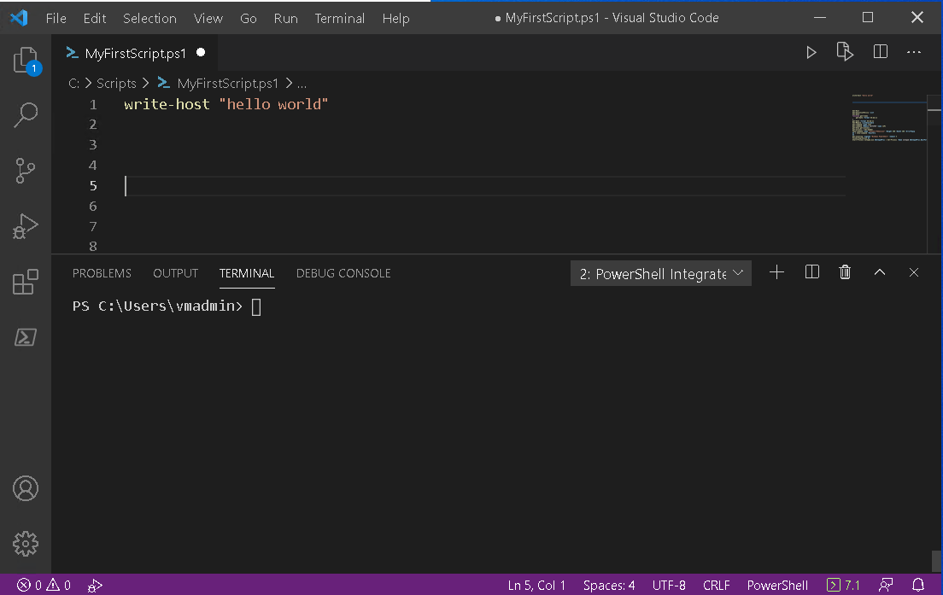
Note: Always select and hit F8 key to run each command separately
Step 2: Once the whole setup is done, run the file and observe the changes made inside the terminal. Try using the path of your Script C:\Scripts\MyFirstScript.ps1 inside the terminal to call the script and check what happens.
Step 3: Type in Get-ExecutionPolicy -List and check what it shows.
Step 4: To check the date and time execute the following commands
Get-Date
Get-Date -format hh:mm:ss

Step 5: Try
Function get-time
{
get-date -format hh:mm
}
get-time
select and run the command using F8 key.
Step 6: Type in command Get-Module -ListAvailable and observe the running terminal to check the packages of functions you have
Step 7: Try Get-Command after running the command run Get-Command -Name *IP* and Get-Command -Module NetTCPIP -Name *IP*.
Step 8: Enter the command below inside your script
Start-Process notepad.exe
$NotepadProc = Get-Process -Name notepad
$NotepadProc.WaitForExit()
StartProcess calc.ex
Step 9: Pipe commands: run Get-Process | Get-Member inside your script.

